20.Implementation of IoT based Smart Agriculture using MATLAB

1. AIM
To simulate an IoT-based Smart Agriculture system using MATLAB that monitors parameters such as soil moisture and temperature, and automatically controls irrigation.

2. SOFTWARE REQUIRED
- MATLAB (any version)
- Optional: Thingspeak IoT Toolbox (not required for simple simulation)

3. THEORY (Simple)
IoT-based smart agriculture uses sensors and automation to improve farming.
Typical system includes:
Sensors
- Soil moisture sensor
- Temperature sensor
- Humidity sensor
Controller
- Microcontroller or IoT node (e.g., NodeMCU, ESP8266)
Actions
- Turn water pump ON when soil is dry
- Turn pump OFF when moisture is sufficient
Key Concept
$$\text{Irrigation ON if moisture < threshold} \\ \text{Irrigation OFF if moisture ≥ threshold}$$
MATLAB can simulate:
- Sensor readings
- IoT decision logic
- Automated irrigation behavior

4. PROCEDURE (Simple)
- Generate simulated sensor data (moisture, temperature).
- Set moisture threshold (e.g., 40%).
- Implement decision logic:
  - If moisture < 40 → Pump ON
  - Else → Pump OFF
- Plot sensor values and pump status.
- Display final irrigation decisions.

5. PSEUDOCODE
Set moisture threshold = 40
Generate random moisture and temperature values

For each reading:
If moisture < threshold:
pump = ON
Else:
pump = OFF

Display results
Plot readings

CODE:
clear; clc; close all;

%% PARAMETERS
timeSteps = 1:50; % simulation duration
soilMoisture = zeros(size(timeSteps));
temperature = zeros(size(timeSteps));
pumpStatus = strings(size(timeSteps));

moistureThreshold = 40; % below this pump turns ON
pump = 0; % 0 = OFF, 1 = ON

%% SIMULATION LOOP
for t = timeSteps

% 1. Simulated sensor readings
soilMoisture(t) = 30 + 20*rand; % range: 30–50%
temperature(t) = 20 + 10*rand; % range: 20–30 °C

% 2. IoT control logic (Irrigation)
if soilMoisture(t) < moistureThreshold
pump = 1; % turn ON
else
pump = 0; % turn OFF
end

pumpStatus(t) = pump;
end

%% DISPLAY LAST SENSOR VALUES
disp('Latest IoT Sensor Data:');
fprintf('Soil Moisture = %.2f%%\n', soilMoisture(end));
fprintf('Temperature = %.2f°C\n', temperature(end));
fprintf('Pump Status = %s\n', pumpStatus(end));

%% PLOT RESULTS
figure;
subplot(3,1,1);
plot(timeSteps, soilMoisture, 'LineWidth', 2);
ylabel('Soil Moisture (%)');
title('IoT Based Smart Agriculture Simulation');
grid on;

subplot(3,1,2);
plot(timeSteps, temperature, 'LineWidth', 2);
ylabel('Temperature (°C)');
grid on;

OUTPUT: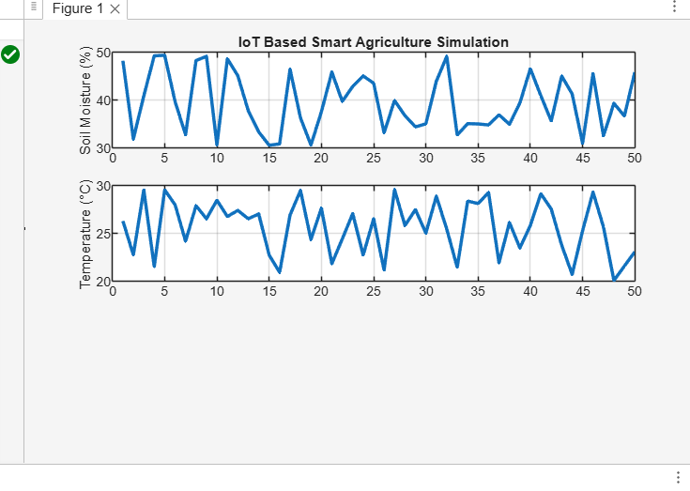

RESULT:
• The IoT-based smart agriculture system successfully monitors soil moisture using MATLAB simulation.
• When moisture falls below the threshold, the system automatically turns the irrigation pump ON.
• When moisture is sufficient, the pump is turned OFF, saving water.
• The simulation proves how IoT helps in smart, efficient, and automated farming.

